--=================================================================================
--===============================CIS 310 ASSIGNMENT 2===============================
--=================================================================================
/*
STUDENT NAME: Dylan Shea
STUDENT ID: 5505131
SUBMISSION DATE: 1/20/24
*/
1. For the database shown below, answer the following 3 questions: (10 pts)
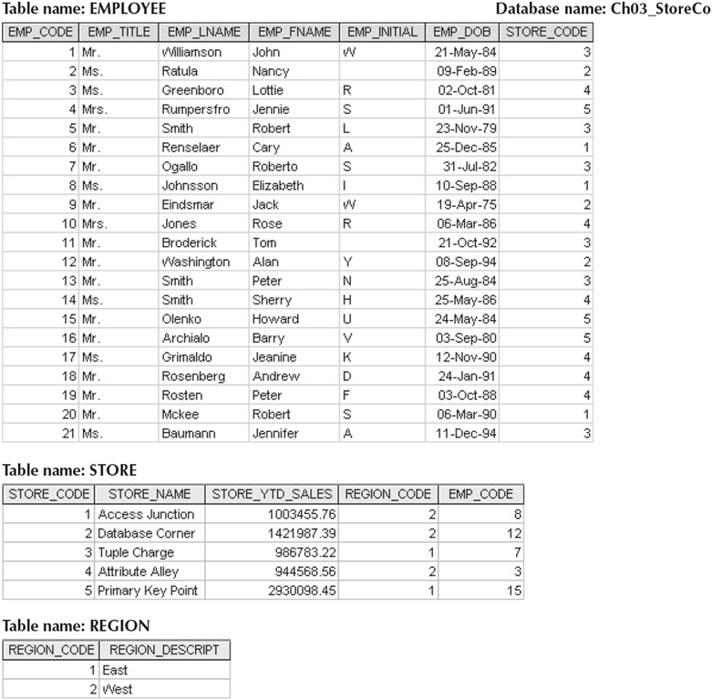
- For each table, identify the primary key and the foreign key(s) by filling in below table. If a table does not have a foreign key, write None.
TABLE | Primary Key | Foreign Key(s)
EMPLOYEE | EMP_CODE | STORE_CODE
STORE | STORE_CODE | EMP_CODE + REGION_CODE
REGION | REGION_CODE | None
- Do the tables exhibit entity integrity? Answer yes or no, and then explain your answer by filling out below table.
TABLE | Entity Integrity | Explanation
EMPLOYEE | Yes | No repetitive data in the table
STORE | Yes | No repetitive data in the table
REGION | Yes | No repetitive data in the table
- Do the tables exhibit referential integrity? Answer yes or no, and then explain your answer by filling out below table. Write NA (Not Applicable) if the table does not have a foreign key.
TABLE | Referential Integrity | Explanation
EMPLOYEE | Yes | EMP_CODE matches in the store table
STORE | Yes | EMP_CODE and REGION_CODE follows the same pattern in both tables
REGION | No | NA

- 2. Write the business rules for the relationships you identify in Figure from Question 1. (10 pts)
- --*Hint, there can be more than 1 relationship between 2 entities. Take a closer look at Employee and Store.
Store – Employee
BR1: Each Store can have one or many employees.
BR2: Each employee can work for one and only one store.

Store – Employee
BR1: each employee manages one and only one store
BR2: each store is managed by one and only one employee

Store – Region
BR1: Each store is in one and only one region.
BR2: each region has one or many stores.

- 3: Create a full ERD using MS Visio for the database in Question 1. All required elements as covered in class must be included for full credit. Other tools such as hand drawn will receive partial credit. (10 pts)
